Part 1 Research Question
1. Research Question: What factors influence churn and can be used to predict churn?
2. Goals of Analysis:
- Identify variables that can be used to accurately predict churn and reduce the model for better interpretation.
- Identify direction and degree of relationship between explanatory and response variables so we can determine how the variables and their interactions influence churn.
- Interpret model coefficients in combination with insights of goal 2 to determine what variables and interactions influence churn the most in each direction. 1 influencing higher churn rates, 1 influencing lower churn rates or one variable that has a significant effect on churn compared to other variables.
Overall, we want to gain insight into what the main influential variables are and how they influence churn.
Part 2 Method Justification
1. Four Assumptions of Logistic Regression Model
- Independence of errors
- Linearity in the logit for continuous variables
- Absence of multicollinearity
- Lack of strongly influential outliers
2. Benefits of using Python for Analysis
Python has libraries that allow us to make logistic regression models by simply writing an expression without us having to do any manual calculations. Not that a perfect model will be made every time, but if we understand the assumptions of the model and adhere to them then we can make an accurate predictive model.
One additional advantage of using python is the Jupyter Notebook GUI separates code sections like a journal so you can process a bunch of calculations in one cell and visualize the transformations or calculations in the next cell.
3. Why are we using Logistic Regression to calculate churn?
Logistic regression calculates the probability of a Binary response outcome given explanatory variable values. The predicted value will always be the most probable binary value calculated using the model. We use logistic regression for binary predictions and churn is a binary variable so logistic regression is our tool of choice.
Part 3 Data Preparation
1. Data Cleaning Goals
Remove outliers with absolute value of z-score greater or equal to 3
Remove missing values
Data transformation section will pertain to variable selection/transformation in the initial model, but code is in the next section.

Code
# Assessing outliers
# Finds Numeric Explanatory Columns
cols_numeric = [x for x in data.columns if (data[x].dtype != 'object') & (x != 'Churn')]
# Iterates through numeric columns calculating z scores
# Tracking outlier indexes in index
for i in cols_numeric:
z = list(stats.zscore(data.loc[:,i]))
ind = []
for zscore in z:
if (zscore >= 3) | (zscore <= -3) & (z.index(zscore) not in ind):
ind.append(z.index(zscore))
if len(ind) > 0:
drop = np.unique(ind)
data = data.drop(index = drop,axis = 0).reset_index(drop = 'True')
#Removing negative values from outage_sec_perweek
for lab,row in data.iterrows():
if data.loc[lab,'Outage_sec_perweek'] < 0:
data.loc[lab,'Outage_sec_perweek'] = 0
print(data.columns)
print(data['InternetService'].value_counts())
data.corr()
# One Hot Encoding to test Multicollinearity
internet_service = ['Fiber Optic', 'DSL', 'None']
contracts = ['One year', 'Month-to-month', 'Two Year']
# Recursion and List comprehension to iteratively apply one hot encoding
for lab,row in data.iterrows():
service,contract = data.loc[lab,['InternetService','Contract']]
# 1 indicates the present value
data.loc[lab,service] = 1
data.loc[lab,contract] = 1
zeros =([i for i in contracts if i not in contract],[i for i in internet_service if i not in service])
# 0 indicates the values that were not in the record
for col in zeros:
for val in col:
data.loc[lab,val] = 0
data = data.drop(columns = ['InternetService','Contract'])
# Ordinal Encoding of Binary Variables
map_cols = ['Churn',
'Multiple', 'OnlineBackup',
'OnlineSecurity', 'StreamingTV',
'StreamingMovies', 'DeviceProtection']
# Iterates through columns mapping 1 to yes values and 0 to no values
for i in map_cols:
data[i] = data[i].map({'Yes':1,'No':0})
2. Summary Statistics of Initial Model Variables
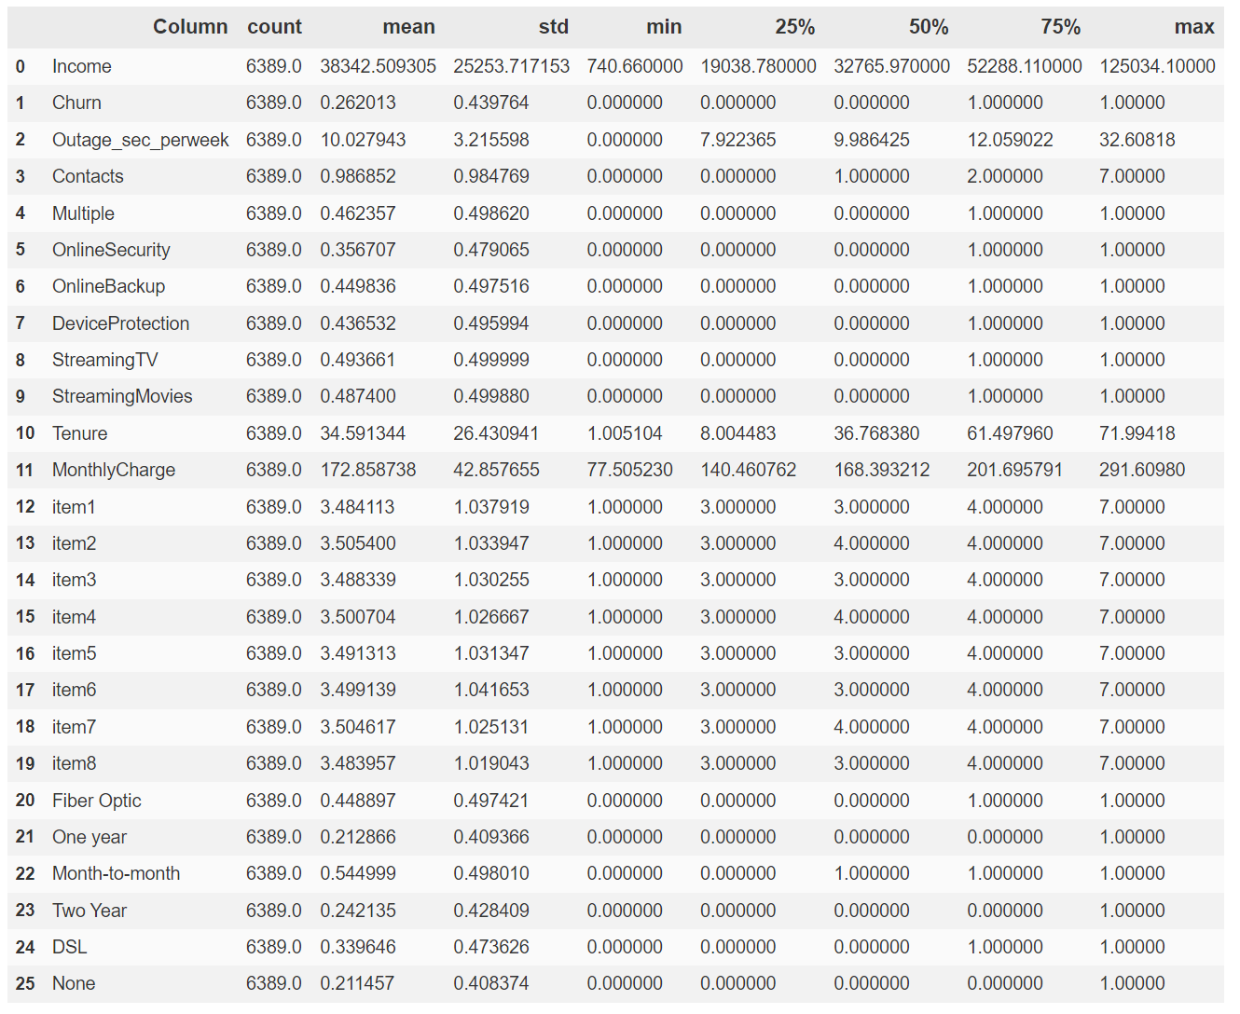 3. Visualizations
Univariate Distributions

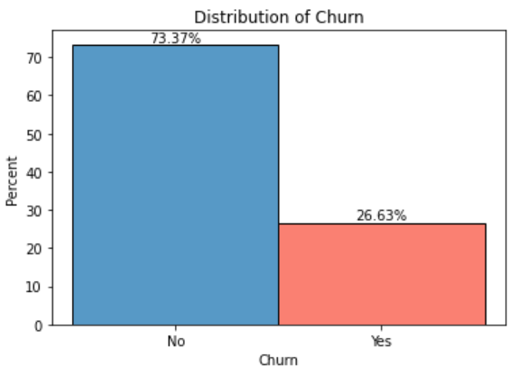

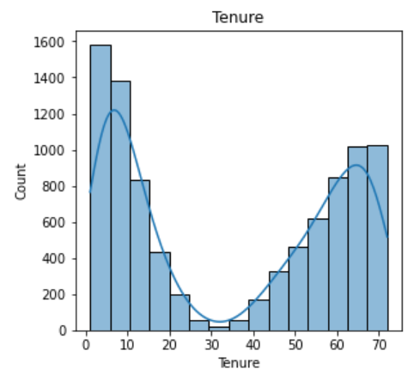 | 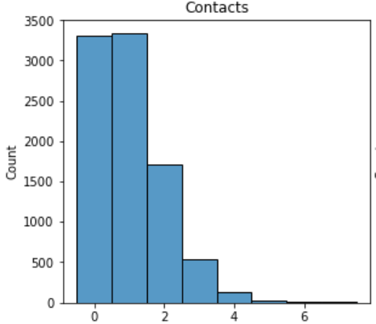
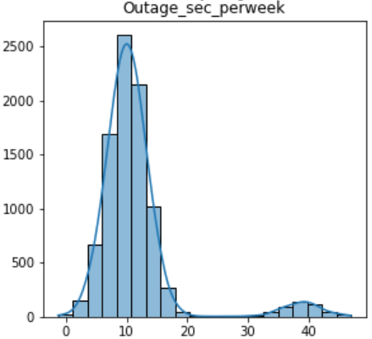 | 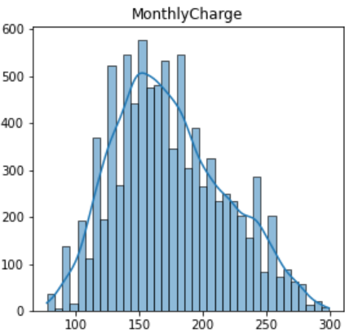
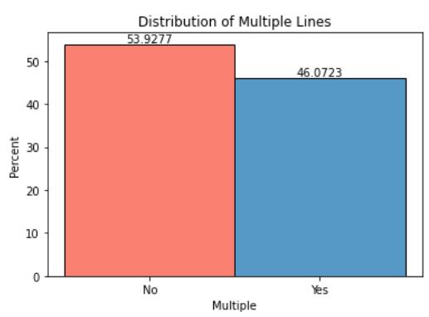
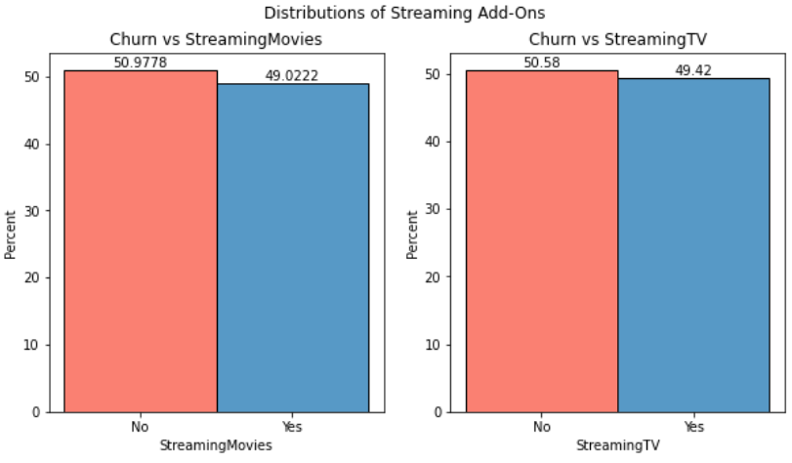

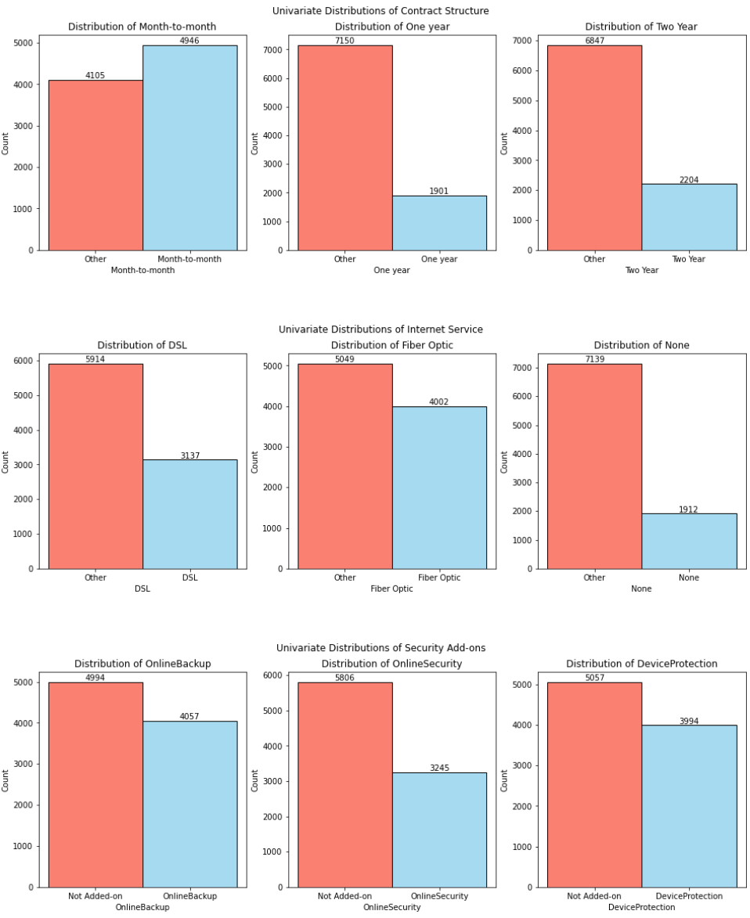

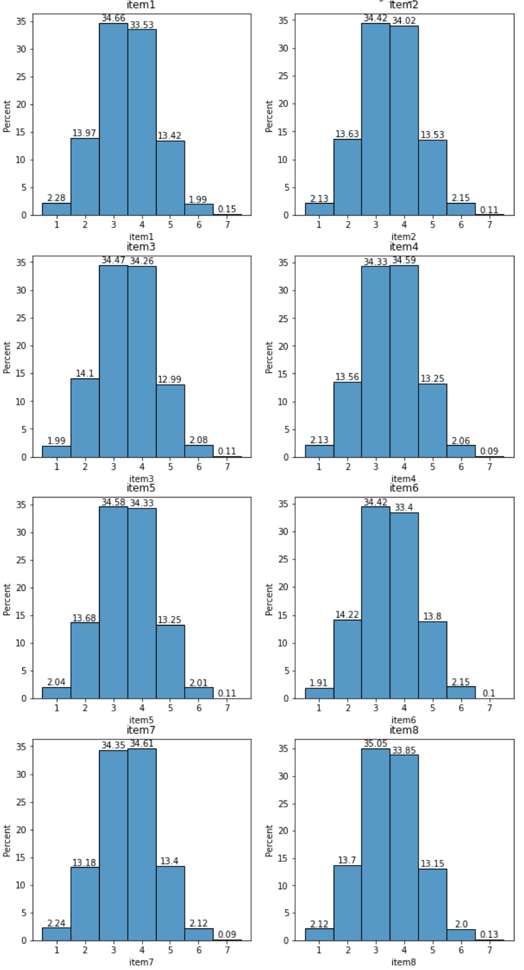

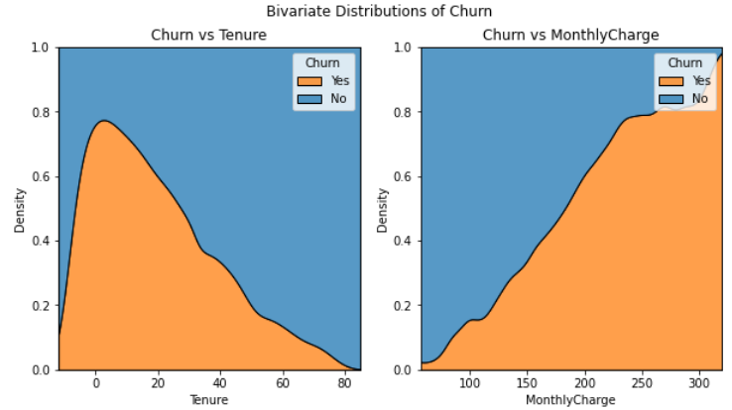
Bivariate Distributions

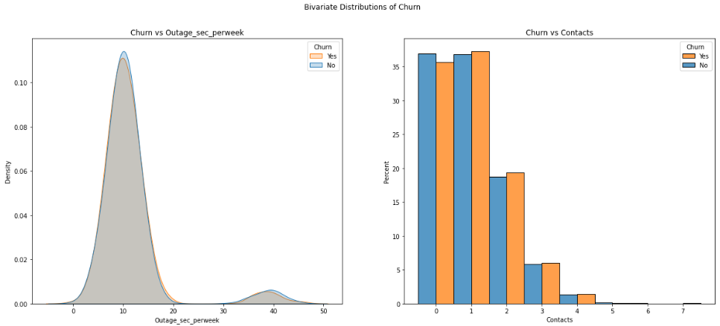

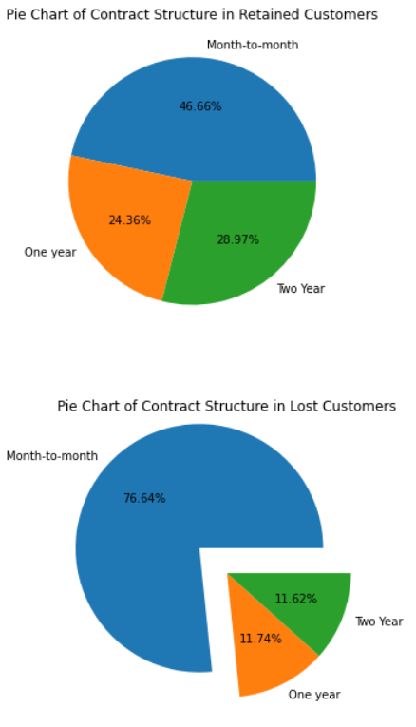
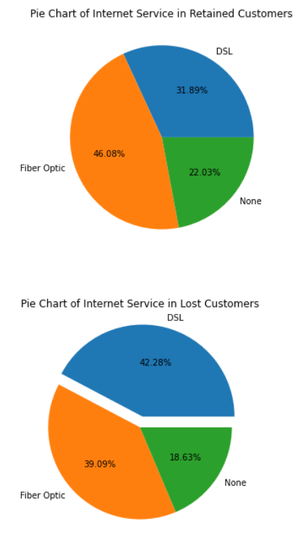

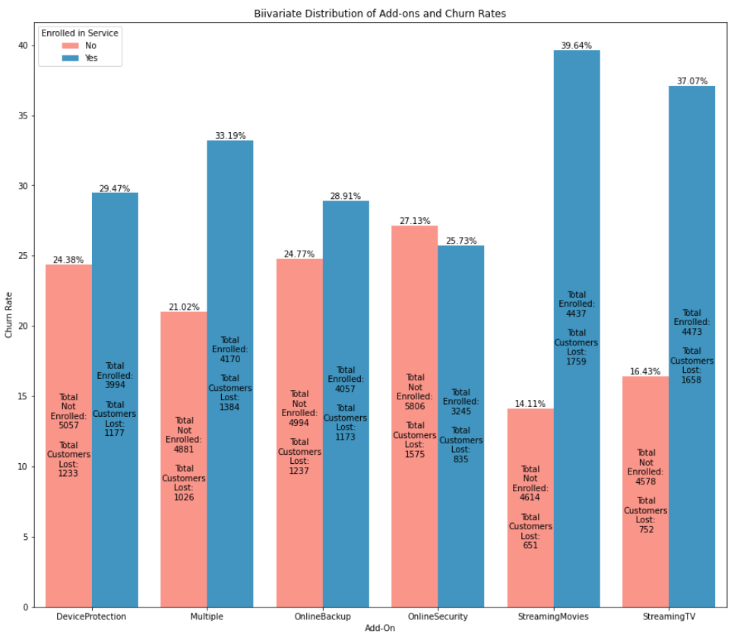

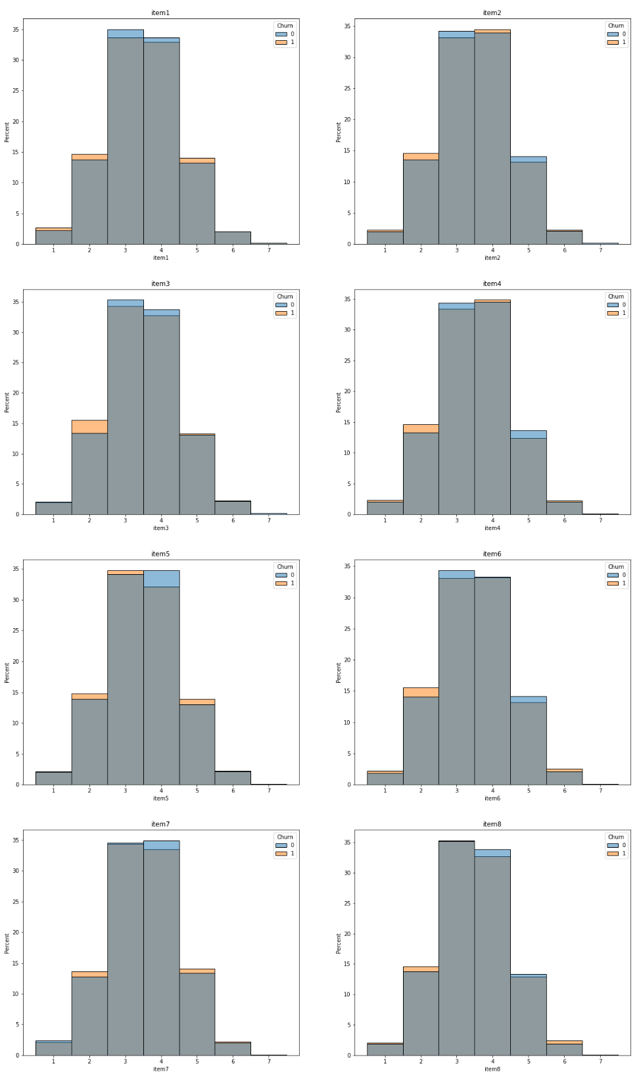
4. Data Transformation Goals
Transform item1-item8 into one column that is the average of all survey responses called survey. This will remove multicollinearity between the survey responses.
Second, I want to use one-hot encoding on the categorical variables with more than 2 values so I can assess VIF for each value in the category. Part of one-hot encoding requires me to remove the other factors from the model because they will be perfectly correlated with one another in the regression model violating the multicollinearity assumption. For the one-hot encoded variables I will be keeping the DSL category from Internet Service and Month-to-month from Contract. I selected these variables because in the visuals above we see the largest variance between churn rates for people with DSL internet and month-to-month contracts and they have the most significant enrollment for churned customers. For better execution of the logit statement and iterative process of feature selection I will be renaming columns removing spaces and dashes. Month-to-month is now monthly, One year is now Annual, Two Year is now Biannual.
Streaming Movies and Streaming TV have high correlation with Monthly Charge, the two columns will be consolidated under streaming which counts how many streaming services the customer is enrolled in.
I will sample 3000 customers with replacement, comprised of 1500 customers that did churn and 1500 that did not churn from the cleaned and transformed dataset that is not missing values for any of our predictor variables.
Code
# One Hot Encoding to test Multicollinearity
internet_service = ['Fiber Optic', 'DSL', 'None']
contracts = ['One year', 'Month-to-month', 'Two Year']
# Recursion and List comprehension to iteratively apply one hot encoding
for lab,row in data.iterrows():
service,contract = data.loc[lab,['InternetService','Contract']]
# 1 is set for the column indicating the type of contract and type of internet service
# the customer has
data.loc[lab,service] = 1
data.loc[lab,contract] = 1
zeros =([i for i in contracts if i not in contract],[i for i in internet_service if i not in service])
# 0 indicates the Internet Service and contract types the customer didn't have
for col in zeros:
for val in col:
data.loc[lab,val] = 0
data = data.drop(columns = ['InternetService','Contract'])
# Ordinal Encoding of Binary Variables
map_cols = ['Churn',
'Multiple', 'OnlineBackup',
'OnlineSecurity', 'StreamingTV',
'StreamingMovies', 'DeviceProtection']
# Iterates through columns mapping 1 to yes values and 0 to no values
for i in map_cols:
data[i] = data[i].map({'Yes':1,'No':0})
np.random.seed = 10000
dfs = [data[data['Churn'] == 0],data[data['Churn'] == 1]]
samples = []
for i in dfs:
inds = np.random.choice(i.index,size = 1500, replace = True)
samples.append(inds)
sample = []
for i in samples:
sample.extend(i)
np.random.shuffle(sample)
sns.histplot(data = sample)
plt.show()
sample = data.loc[sample,:].copy(deep = True).reset_index(drop = True)
sample
#Creating a list to iterate through
items = [x for x in data.columns if 'item' in x]
# For each row the survey item1-item8 will be averaged
for lab,row in sample.iterrows():
sample.loc[lab,'Survey'] = sample.loc[lab,[x for x in sample.columns if 'item' in x]].mean()
sample.loc[lab,'Streaming'] = (sample.loc[lab,'StreamingMovies'] + sample.loc[lab,'StreamingTV'])
#Changing the names of the columns removing spaces and dashes
sample = sample.rename(columns = {'Fiber Optic': 'FiberOptic','Month-to-month': 'monthly','Two Year': 'Biannual','One year':'Annual'})
sample['Churn'].map({1:'Yes',0:'No'})
Part 4 Model Comparison and Analysis
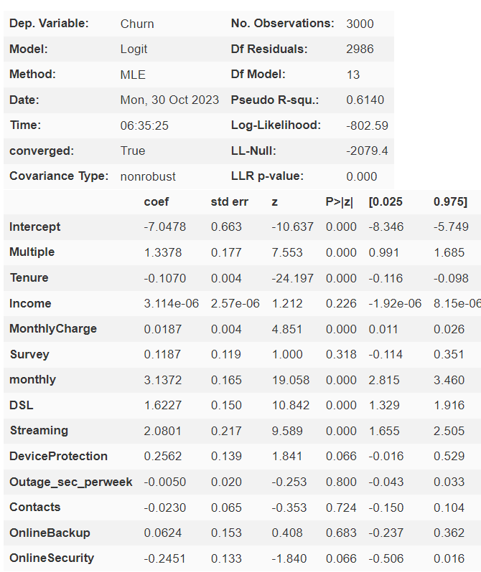
D Comparison of Initial model and Reduced
- Initial model
The Initial model expression is Churn ~ Multiple + Tenure + Income + MonthlyCharge + Survey + monthly + DSL + Streaming + DeviceProtection + Outage_sec_perweek + Contacts + OnlineBackup + OnlineSecurity
P-values higher than .05 are likely not boosting accuracy of our model and the coefficients don’t provide predictive power. In our next section of feature selection we will be eliminating variables that do not provide strong predictive power for the Logistic Regression Model.

- Feature Selection Method

I will be using a forward selection method. This process allows us to iteratively select the most influential feature for prediction accuracy. Iterating through forward selection manually allows us to have more control and determine whether we want to continue adding additional features to the model at each iteration. Intermediate Variance Inflation Factor calculations will be done, preventing the addition of features when there is a VIF of 10 or higher with the other features added to the model. This will help us work under one of the assumptions of logistic regression by eliminating multicollinearity. Removing multicollinearity improves our prediction accuracy across diverse datasets as this factor in regression creates heavy overfitting. After features have been vetted with VIF we can add it to the model if it passes the test or remove it from consideration for future iterations of forward selection which improves the processing speed of the selection process.

- Reduced Model and Output for Both Models

Expression: Churn ~ Tenure * MonthlyCharge * monthly * FiberOptic

Reduced Model Regression Summary
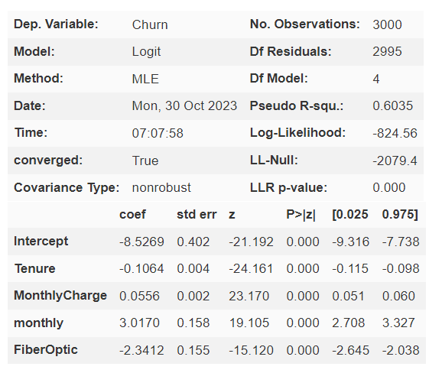
VIF values for reduced model

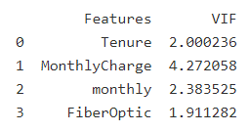

E Analysis and Comparison of Regression Models
Model Evaluation Metric Outputs and Analysis
- Model Evaluation using Performance Metrics
Both Models performed similarly indicating the Initial Model was a bit bloated with unnecessary features. The Initial Model performs slightly better. Both models perform slightly better at predicting whether someone will churn or not. The performance is a bit worse at predicting if someone didn’t churn.
The two models have a high ROC AUC score of .957 which indicates the model does an exceptional job at distinguishing customers who churn and customers who don’t churn from one another.
- Output of Calculations and Code

Initial Model Metrics
accuracy: 0.882
sensitivity: 0.901
specificity: 0.862
Confusion Matrix
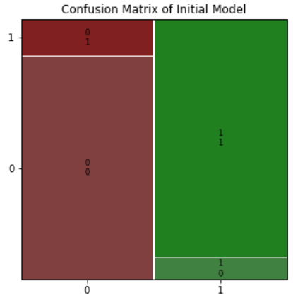
Reduced Model Metrics
accuracy: 0.88
sensitivity: 0.897
specificity: 0.864
Confusion Matrix
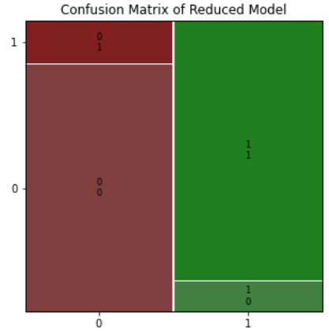
Comparison of Confusion Matrices
Initial | True | False
True | 1294 | 206
False | 143 | 1357

Reduced | True | False
True | 1296 | 204
False | 155 | 1345

The reduced model lowered prediction accuracy a negligible amount, the simpler interpretation of coefficients makes the reduced model more valuable however because we dropped 9 features and lost 1 percent in accuracy.
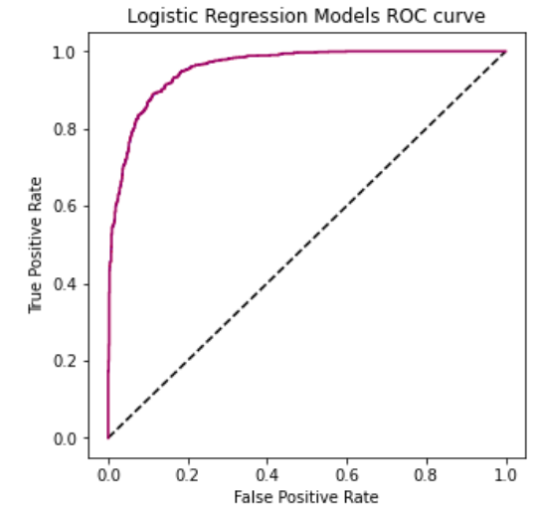
Code
#Initial Model Accuracy Metrics
conf_matrix = mdl.pred_table()
TN = conf_matrix[0,0]
TP = conf_matrix[1,1]
FN = conf_matrix[1,0]
FP = conf_matrix[0,1]
# Calculate and print the accuracy
accuracy = (TN + TP) / (TN + FN + FP + TP)
print("accuracy: ", accuracy)

# Calculate and print the sensitivity
sensitivity = TP / (TP + FN)
print("sensitivity: ", sensitivity)

# Calculate and print the specificity
specificity = TN / (TN + FP)
print("specificity: ", specificity)

#Reduced Model
expression = 'Churn ~ Tenure * MonthlyCharge * monthly * FiberOptic'
reduced = logit(expression, data = sample).fit()
# Performance Statistics
print('Expression:')
print(expression)
conf_matrix = reduced.pred_table()
TN = conf_matrix[0,0]
TP = conf_matrix[1,1]
FN = conf_matrix[1,0]
FP = conf_matrix[0,1]
# Calculate and print the accuracy
accuracy = (TN + TP) / (TN + FN + FP + TP)
print("accuracy: ", accuracy)

# Calculate and print the sensitivity
sensitivity = TP / (TP + FN)
print("sensitivity: ", sensitivity)

# Calculate and print the specificity
specificity = TN / (TN + FP)
print("specificity: ", specificity)
#Visualize Confusion Matrices
rcParams['figure.figsize'] = 5, 5
mosaic(mdl.pred_table())
plt.title('Confusion Matrix of Initial Model')
print(mdl.pred_table())
plt.show()
mosaic(reduced.pred_table())
plt.title('Confusion Matrix of Reduced Model')
print(reduced.pred_table())
plt.show()
print(f'Difference from Initial Model:\n{mdl.pred_table() - reduced.pred_table()}')
from sklearn.metrics import roc_curve
from sklearn.metrics import roc_auc_score
fpr, tpr, thresholds = roc_curve(sample.Churn,mdl.predict(sample))
plt.plot([0,1],[0,1],'k--')
plt.plot(fpr,tpr,label = 'Logistic Regression',color = 'red')
fpr, tpr, thresholds = roc_curve(sample.Churn,reduced.predict(sample))
plt.plot(fpr,tpr,label = 'Logistic Regression',color = 'blue',alpha = .4)
plt.xlabel('False Positive Rate')
plt.ylabel('True Positive Rate')
plt.title('Logistic Regression Models ROC curve')
plt.show()
print(f'ROC AUC Score Initial Model:{roc_auc_score(sample.Churn,mdl.predict(sample))}')
print(f'ROC AUC Score Reduced Model:{roc_auc_score(sample.Churn,reduced.predict(sample))}')
- File is included in submission see Logistic Regression PA
File contains code for all visuals, regression models, feature selection processes and calculations/analysis performed.
Part 5 Data Summary and Implications
F Summary of Findings
1.
Regression Equation:
Logit(p) = -8.53 + Tenure * -.1064 + .0556 * MonthlyCharge + monthly * 3.02 -2.341 * FiberOptic

Coefficients
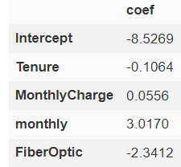

Odds Ratios
We see that someone is less likely to churn if they have the Fiber Optic Internet Service. We can also determine that people with more tenure are less likely to churn because of the negative sign. Monthly contracts are more likely to churn. When calculating odds of churn for people with monthly contracts we can find that they are 20x more likely to churn than those with a different plan, but when customers who have Fiber Optic internet service and a monthly plan are only 2x more likely to churn. Fiber Optic reduces the odds of churn by a factor of 10. Since DSL isn’t in the model, we can’t estimate how much it influences churn, but we have our Bivariate Internet Service Pie Charts on page 8. This displays that people with DSL are more likely to churn than Fiber Optic and None. There seems to be a trend in customers leaving the company to get a Fiber Optic plan, the monthly contract structure clearly allows for the customer to leave at will rather than forcing them to sit through a year-long contract.

- Statistical Significance of Reduced Model
Our model is effective at assessing churn influencers because we got an accuracy score of 88.4%. This score is perfect because our model shouldn’t perfectly predict every value, because that would indicate we are having the problem of overfitting. We have slightly more success at assigning whether someone will churn rather than if someone does not churn with a sensitivity score of 90%, and a specificity score of 86.3%. All our reduced model coefficients have a significant influence on the model predictions with p-values close to 0. Our ROC AUC score of .957 is a very high score and also indicates that we have a model that can correctly distinguish whether someone will churn or not with a high probability.
2. Limitations of Model
Models in development tend to not perform well over extended periods of time due to how industries shift over months, quarters, and years, so there will have to be some KPI metrics to supervise the performance of the model as different features lose their linear relationships and other variables become stronger predictors. If the reduced model features lose a linear relationship with churn we won’t be able to use them in a logistic regression model to predict churn anymore.
3. Course of Action
This model can be a generative tool to develop and manage a KPI to find customers in the database that are at high risk of leaving. If the model performance appears to be dipping after being in development for a few months or years, this is an indication that the model needs to be rebuilt using different features to capture the new linear relationships of churn. This may also entail using another ML model (Support Vector Machines, KNN, Decision Trees) to predict churn if the features’ relationships with churn lose linearity. As business models tend to change as trends change, we need to tune the model frequently to keep the model in tune with current data. Tuning can simply be done using the forward selection method I used, and we need the data in a similar format. Adding KPIs for churn or business metrics may or may not improve the model over time as well, so a lot of trial and error and computing power may need to be used for sustaining optimal performance. Overall the model is a great tool in finding the key influencers of churn.

